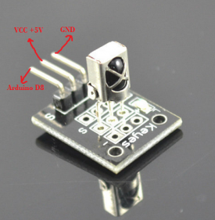
IR receiver sensor can get signal from infrared sender device such as remote controller of TV,DVD. In this project, we will use a TV remote controller to send IR signal to IR receiver. The first push of the TV remote button will light up the LED in the receiver circuit, the second push will turn off the LED.
Step 1: Connect the circuit as per following graph:
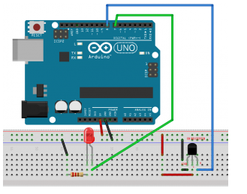
Step 2 – If you don’t have IRremote library, Download IRremote Library, and then import the library into Arduino IDE(in Arduino IDE->Sketch->Import Library->Add Library). If you have already installed this library, please skip this step.
Step 3: Download the sample code and load it into Arduino.
Step 4: test the project. push any button in a remote controller, the LED will be turn on. Push any key again, the LED will be turn off.

